Project Design Phase-II

Data Flow Diagram & User Stories

|  |  |
| --- | --- |
| Date | 17-October-2023 |
| Team ID | NM2023TMID07556 |
| Project Name | IPhone Revolution |
| Maximum Marks | 4 Marks |

# Data Flow Diagrams:

A Data Flow Diagram (DFD) is a traditional visual representation of the information flows within a system. A neat and clear DFD can depict the right amount of the system requirement graphically. It shows how data enters and leaves the system, what changes the information, and where data is stored.

# Example: [(Simplified)](https://developer.ibm.com/patterns/visualize-unstructured-text/)

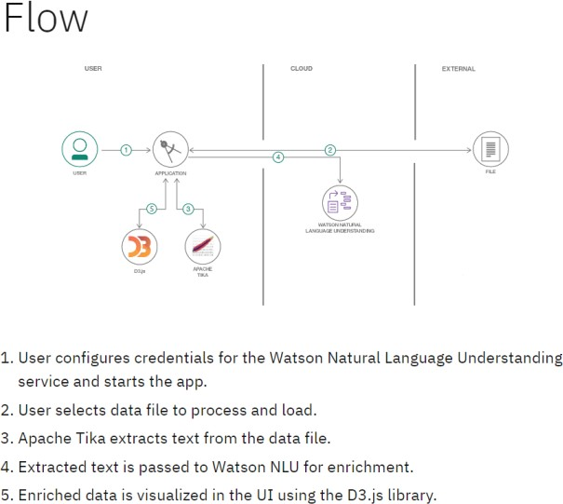

DATA FLOW DIAGRAM

PUBLIC USER

**User Stories**

Use the below template to list all the user stories for the product.

|  |  |  |  |  |  |  |
| --- | --- | --- | --- | --- | --- | --- |
| **User Type** | **Functional**  **Requirement (Epic)** | **User Story Number** | **User Story / Task** | **Acceptance criteria** | **Priority** | **Release** |
| PUBLIC | Public users can access the iPhone Revolution platform to learn about the history and impact of the iPhone on technology and society. | USN-1 | As a public user, I want to be able to visit the iPhone Revolution website and explore the information about the history and impact of the iPhone | The website should provide a user-friendly interface that allows public users to easily access information about the iPhone's history and impact. | o/1 | iPhone Revolution Store Version 1.0 |
| Public users can engage with the iPhone Revolution platform to enhance their understanding of the iPhone's historical significance. | USN-2 | As a public user, I want to be able to browse a timeline that highlights key milestones and innovations in the history of the iPhone. | The platform should feature an interactive timeline that displays significant events and developments in the iPhone's history, allowing users to explore and learn about them. | 0/1 |
| USN-3 | I want the option to share interesting content or articles from the platform on my social media accounts to inform and engage with my network. | There should be easy-to-use social sharing buttons or options that enable users to share content from the platform to their social media profiles. | 0/1 |
|  | Dashboard |  |  |  |  |  |
| System Administrator | System administrators are responsible for managing and maintaining the technical infrastructure of the iPhone Revolution platform, ensuring its availability, security, and performance. | USN-1 | As a system administrator, I want to set up and configure the server infrastructure required to host the iPhone Revolution platform. | The server infrastructure should be set up with appropriate configurations, ensuring the platform's availability and performance. | 0/1 | iPhone Revolution Store Maintenance Version 1.0 |
| USN-2 | As a system administrator, I want to regularly apply software updates and security patches to keep the platform secure and up-to-date. | software updates and security patches should be applied in a timely manner to keep the platform secure and current. | 0/1 |
| USN-3 | As a system administrator, I want to monitor server performance, detect and resolve any technical issues promptly, and optimize server resources as needed. | server performance should be monitored, and any issues should be addressed promptly to maintain platform efficiency. | 0/1 |